Lab 4
EtherChannel and DHCP
Objective:
The purpose of this lab is for the student to understand, create and implement EtherChannel connections and DHCP. Students will also utilize IOS commands to explore and configure EtherChannel connections and DHCP on network routers and switches.
Diagram:
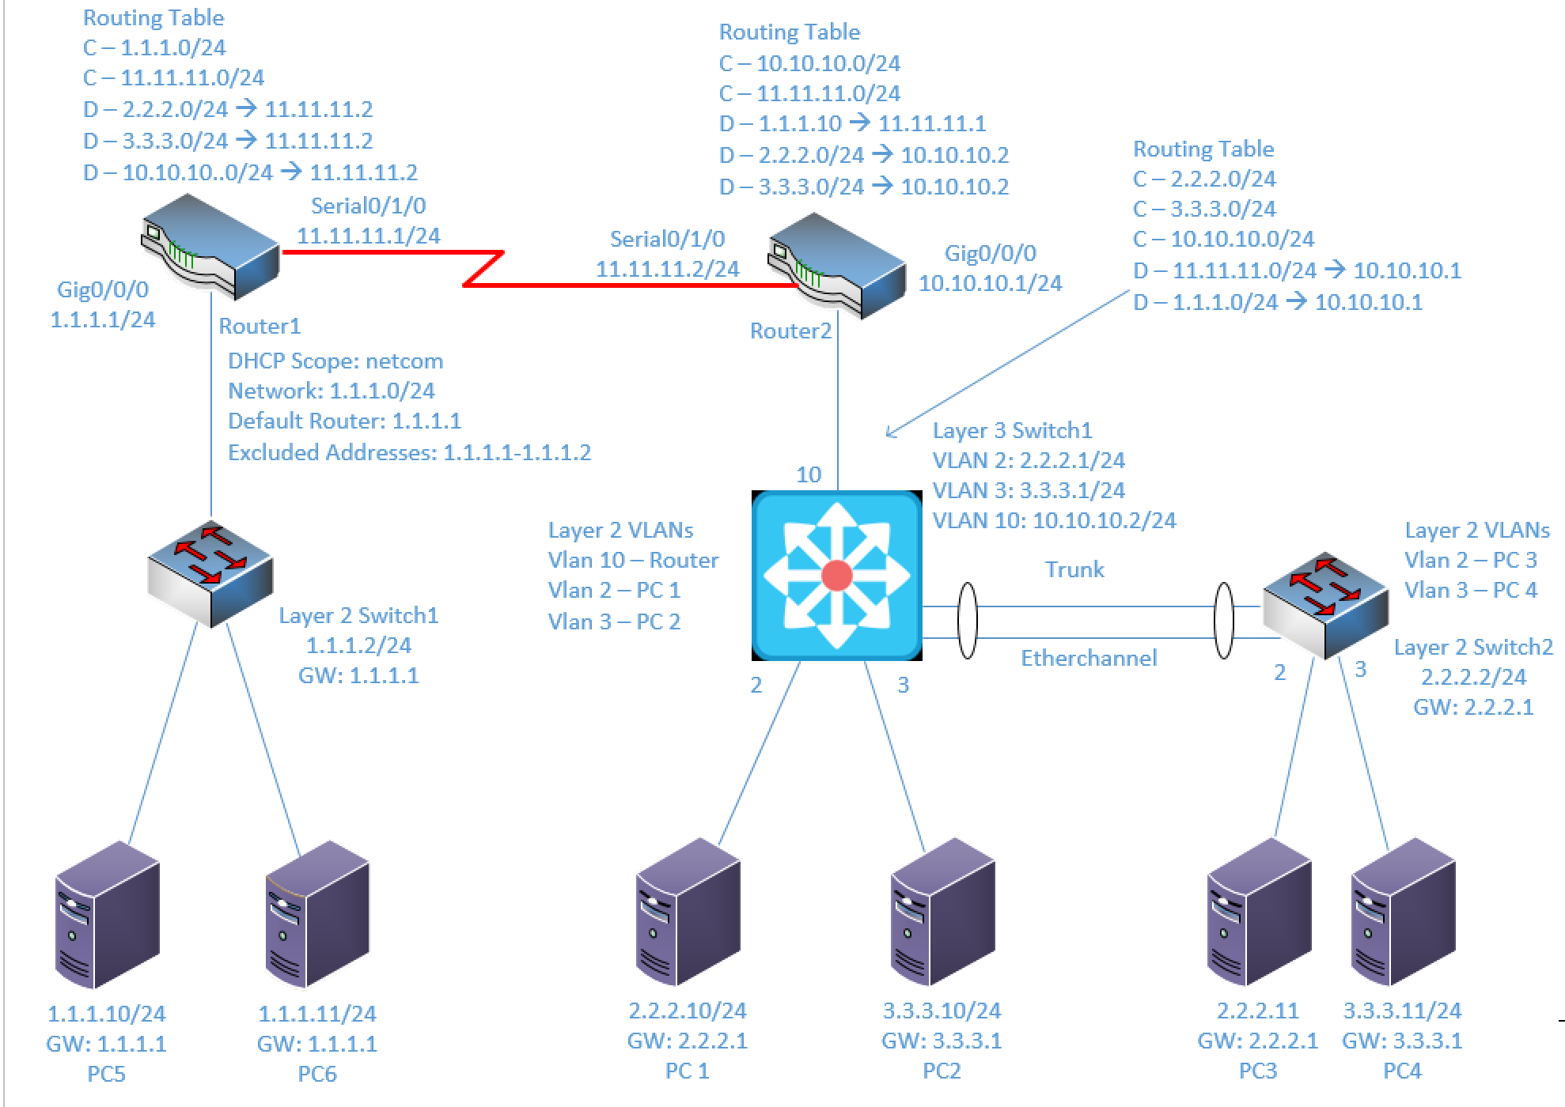

Components:
6 – PC’s with an Ethernet NIC
1 – 3650 Layer 3 Switch
2 – 2960 Layer 2 Switches
2 – 4321 Routers (with NIM 2T WAN card)

Useful commands for this lab:
show ip route – view routing table
show vlan – View vlan table and port assignments
show ip interface brief – view status of layer 3 ports
show access-lists – view access lists and hit counters
show etherchannel summary – view port channel status
Add IP address to Serial Interface (same as Ethernet)
interface Serial0/1/0
ip address 5.5.5.1 255.255.255.0
no shutdown

Enable routing on Layer 3 switch
ip routing

PPP – Clock rate only on DCE side
interface serial0/1/0
encapsulation ppp
clock rate 1536000
ip address 1.1.1.1 255.255.255.0
no shutdown

Assign range of ports to port channel
interface range GigabitEthernet1/0/9-10
channel-group 5 mode on

Configure Port Channel for trunking on L3 Switch
interface Port-Channel 5
switchport trunk encapsulation dot1q
switchport mode trunk
no shutdown

Configure Port Channel for trunking on L2 Switch
interface Port-Channel 5
switchport mode trunk
no shutdown

Configure DHCP on Router
ip dhcp pool netcom
network 1.1.1.0 255.255.255.0
default-router 1.1.1.1
ip dhcp excluded-address 1.1.1.1 1.1.1.2

Configure Port Fast on a port
interface GigabitEthernet 1/0/1
spanning-tree portfast

Configure EIGRP
router eigrp 5
network 1.1.1.0 0.0.0.255
network 11.11.11.0 0.0.0.255
no auto-summary

Procedure:
- Connect all PC’s together and put their static IP addresses, subnet masks and gateways on them. Test connectivity by pinging each machine within the network.

- Use the diagram above to label the Layer 3 switches VLAN IP addresses and ports below

Vlan | IP Address | Switch Port
2 | 2.2.2.1/24 | 2
3 | 3.3.3.1/24 | 3
10 | 10.10.10.2/24 | 10
Trunk |  | 21-22

- Use the diagram above to label the routing tables for the Layer 3 switch and routers below.

Router1 | Router2 | Layer3 Switch
C-1.1.1.0/24 | C-10.10.10.0/24 | C-2.2.2.0/24
C-11.11.11.0/24 | C-11.11.11.0/24 | C-3.3.3.0/24
D-2.2.2.0/24-> 11.11.11.2 | D-1.1.1.0/24-> 11.11.11.1 | C-10.10.10.0/24
D-3.3.3.0/24-> 11.11.11.2 | D-2.2.2.0/24-> 10.10.10.2 | D-11.11.11.0/24-> 10.10.10.1
D-10.10.10.0/24-> 11.11.11.2 | D-3.3.3.0/24-> 10.10.10.2 | D-1.1.1.0/24-> 10.10.10.1

- Place the switch ports into the proper vlans. Configure all of the switches vlan IP addresses.
  - Example
interface Gigabitethernet 1/0/1
switchport mode access
switchport access vlan 2
no shutdown
interface vlan 2
ip address 2.2.2.1 255.255.255.0
no shutdown

- Enable routing on the Layer 3 switch

- View the routing table on the Layer 3 switch

- Verify that the PC’s on the switch can ping each other

- Configure the IP addresses on the fastethernet router interfaces and turn the interfaces on

- Plug the DCE cable into the router with the 10.10.10.0/24 and 11.11.11.0/24 networks.

- Plug the DTE cable into the router with the 11.11.11.0/24 and 1.1.1.0/24 networks.

- Make the serial0/0 interfaces on both routers PPP

- Make the serial0/0 interface clock rate 56k on the master

- Place IP addresses on the router serial0/0 interfaces

- Use a dynamic routing protocol (EIGRP or OSPF) on the two routers and Layer 3 switch. Remember: Dynamic routing protocols require a “network” statement for each interface on the device. Also remember the EIGRP autonomous system number should be the same on all devices.

  - Example: Router 1
router eigrp 5
network 1.1.1.0 0.0.0.255
network 11.11.11.0 0.0.0.255
no auto-summary

- View and verify the routing table on both routers and the L3 Switch. Paste below once all 3 L3 devices have all routes.
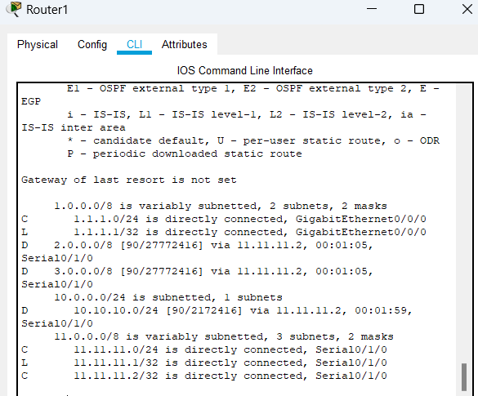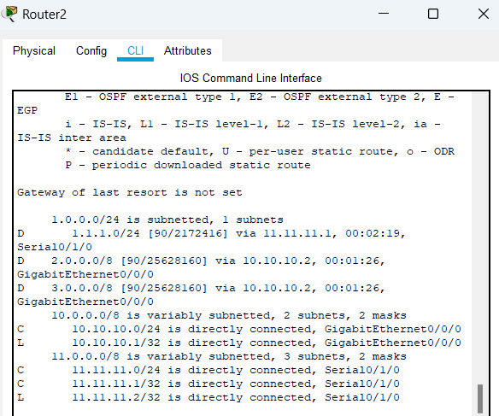
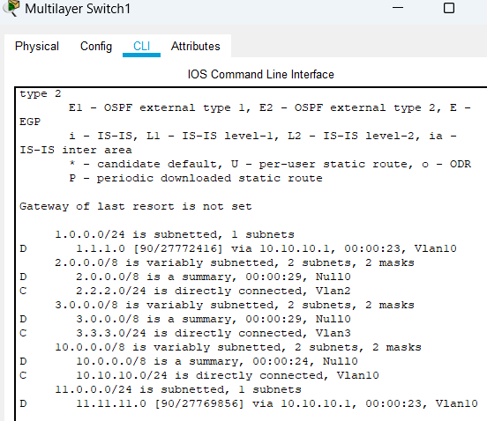

- Connect 2 interfaces on the Layer 3 switch to 2 interfaces on the Layer 2 switch as the diagram shows

- On the Layer 3 switch create an EtherChannel with the 2 ports that were just connected to the Layer 2 switch. Use the mode of on and a channel-group number of 1. My example above uses group 5. Make sure to adjust the commands to meet these requirements (channel-group 1 mode on) and (interface port-channel 1)

  - What commands did you enter?
Interface range fastethernet0/21-22
Channel-group 1 mode on

  - What is the name of the new interface that was created?
Interface Port-channel1
- Select the new interface and place it into trunk mode

  - What commands did you enter?
Interface port-channel1
Switchport trunk encapsulation dot1q
Switchport mode trunk
- View the running configuration
  - Are the physical ports in the port channel also in trunk mode? Yes
  - Why? The ports belong to the port channel, so their settings are changed when we change settings for the channel.

- Verify that all 4 PC’s on the Layer 2 and Layer 3 switch can ping each
other

- Run a continuous ping from 2.2.2.10 to 2.2.2.11
  - Example
ping -t 2.2.2.10
The “-t” will send the ping indefinitely or until “Control + C” is pushed or until the Command prompt window is closed.
- Remove one of the links between the Layer 2 and Layer 3 switch
  - Did the continuous ping continue or stop? It continued
  - Why? The connection was not severed; the etherchannel treats both physical ports as one logical port and therefore the “port” did not lose its connection.

- On the router that has the 1.1.1.0/24 network directly connected, create a dhcp pool with the following settings
  - Pool Name: NetCom
  - Network of 1.1.1.0/24
  - Gateway of 1.1.1.1
  - Exclude IP address 1.1.1.1

- What commands did you enter?
Ip dhcp pool NetCom
Network 1.1.1.0 255.255.255.0
Default-router 1.1.1.1
Exit
Ip dhcp excluded-address 1.1.1.1

- Disconnect the PC’s 1.1.1.10/24 and 1.1.1.11/24 from the switch. Change them to DHCP clients and plug them back in. If the PCs are being stubborn, open a command prompt and enter “ipconfig /renew”

  - Did they receive IP addresses? No, it says DHCP failed
  - How long did it take? It looks like a minute or so

- Disconnect the PC’s 1.1.1.10/24 and 1.1.1.11/24 from the switch. Place the switch ports the PC’s plug into to be portfast

  - What commands did you enter?
Int range fa0/1-2
Sw m a
Spanning-tree portfast

  - Did they receive IP addresses?
Yes
  - How long did it take?
Literally instantly
  - Was this faster than before?
Very much so
  - Why? Because the ports were put into portfast state

- Can every PC ping each other? Yes!

- Create the lab diagram below (PCs, router and switch connections) in Packet Tracer or Visio. Label the IP addresses, subnet masks, and gateways used by each device. Label the routing tables next to the switch and router and the switches vlan IP addresses and port vlan information. Label the port-channel interfaces on the switches.See the diagram at the beginning of the lab for a suggestion on how to do this.

